**NOS PIZZA Normal Petite**

**Margherita Tomates - Mozzarella – Origan 15.00 13,00**

**Jambon Cuit Tomates – Mozzarella – Jambon cuit – Origan 17.50 15.00**

**Napoletana Tomates – Mozzarella – Olives 19.50 15.00**

**Anchois – Câpres – Origan**

**4 Stagioni Tomates – Mozzarella – Champignons – Poivrons 20.00 15.00**

**Jambon cuit – Origan**

**Calzone Tomates – Mozzarella – Jambon cuit-Œuf-Salami 20.00 15.00**

**Capricciosa Tomates – Mozzarella – Jambon cuit – Œuf –**

**Poivron – Champignons 20,00- 1500-**

**Romana Tomates – Mozzarella – Jambon cru 22.00 17.00**

**Diavola Tomates – Mozzarella – Salami piquant 19.50 15.00**

**Crevettes Tomates – Mozzarella – Crevettes 22.50 17.00**

**Vegetariana Tomates – Mozzarella – Légumes 19.50 15.00**

**4 Formaggi Tomates – Mozzarella – Gorgonzola – Gruyère 21.00 17.00**

**Vacherin Fribourgeois**

**Federico Tomates – Mozzarella – Gorgonzola – Salami piquant 21.50 17.00**

**Rondelle Tomates – Basilic**

**Siciliana Tomates – Mozzarella – Thon – Olives – Câpres 22.50 17.00**

**Bolets Tomates – Mozzarella – Bolets – Ail – Basilic 22.50 17.00**

**Frites Tomates-Mozzarella-Pommes Allumette 16.00**

**Italia Tomates-Mozzarella-Jambon Cru 22.50 17.00**

**Parmesan–Roquette -**

**Lardon Tomates – Mozzarella – Lardons – Oignon 20.00 15.00**

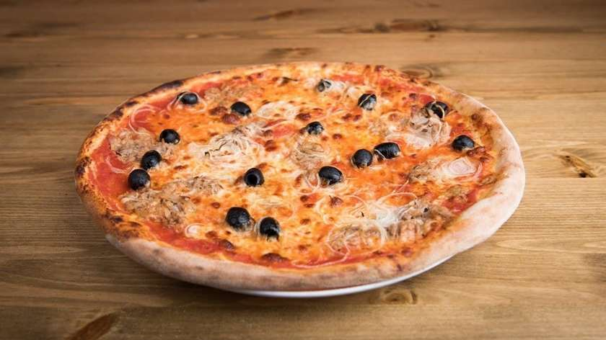 **TVA 8.1 % comprise**