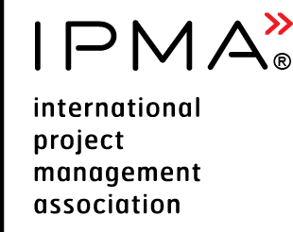 | Report Form (A or B)  Initial Certification | 

Candidate name:

IPMA Level and Domain
Initial Certification (mark only one with✅)
IPMA Level A® |  |  | IPMA Level B®
Certified Project Director |  |  | Certified Senior Project Manager
Certified Programme Director |  |  | Certified Senior Programme Manager
Certified Portfolio Director |  |  | Certified Senior Portfolio Manager

General Information
Your report shall be no more than 25 pages using a font size of 11 points. You may include an additional 15 pages for appendices. Material in the appendices must be cross-referenced to the body of the report.

Background
Provide a detailed description (maximum 3 pages including graphics) of:
- your role;
- key stakeholders;
- scope;
- key objectives;
- project/programme/portfolio organisation; and
- resources that you were responsible for.

Project/programme/portfolio management challenges
Please provide an overview of your management challenges throughout the period of the project/ programme/portfolio. Your report shall address your experience as follows:
- your management and leadership challenges with respect to others;
- how these were acted upon and the results achieved; and
- a reflection on the results and lessons learnt.
You can use the STAR approach (Situation, Task, Action, Result) to structure each competence element in your report.
A total of 80% of competence elements must be referred to throughout the report. You can use VSF FRM 109 Candidate Report Assessment as a supporting material.

Report

Perspective Competences
1. Strategy
2. Governance, structures and processes
3. Compliance, standards and regulations
4. Power and interest
5. Culture and values

People Competences
1. Self-reflection and self-management
2. Personal integrity and reliability
3. Personal communication
4. Relations and engagement
5. Leadership
6. Teamwork
7. Conflict and crisis
8. Resourcefulness
9. Negotiation
10. Results orientation
Practice Competences
1. Project/Programme/Portfolio Design
2. Requirements and objectives (for project domain)
Benefits and objectives (for programme domain)
Benefits (for portfolio domain)
3. Scope
4. Time
5. Organisation and information
6. Quality
7. Finance
8. Resources
9. Procurement (for project and portfolio domains only)
Procurement and partnership (for programme domain)
10. Plan and control
11. Risk and opportunity
12. Stakeholders
13. Change and transformation
14. Select and balance (for programme and portfolio domains only)

