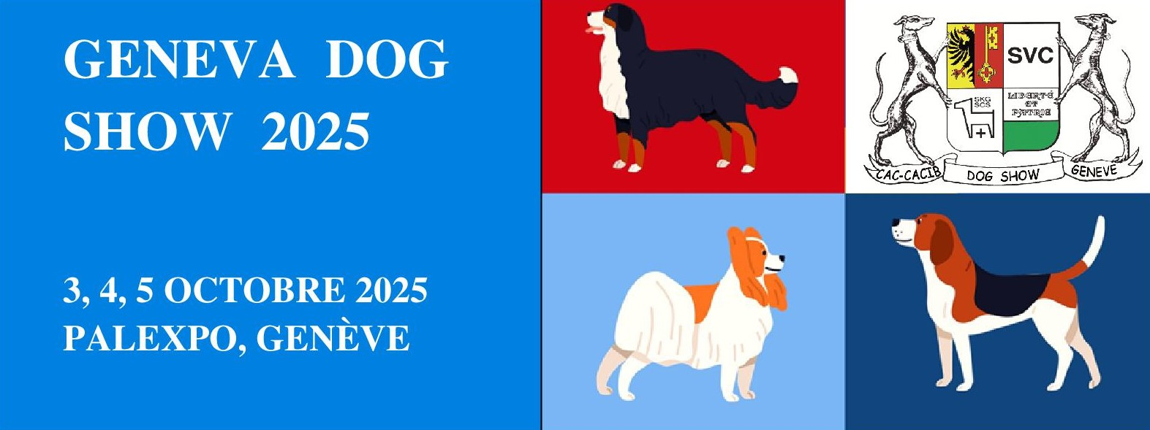

**Program**

Friday morning october 3. 2025

National dog show for all breeds with SCS CAC award.

Friday afternoon october 3. 2025

International dog show for all breeds with awarding of the CACIB of the FCI

and the CAC of the SCS.

Saturday october 4. 2025

International dog show for all breeds with awarding of the CACIB of the FCI

and the CAC of the SCS.

Qualification for the title “Champion of the Alps”

Sunday october 5. 2025

International dog show for all breeds with awarding of the CACIB of the FCI

and the CAC of the SCS.

Cruft 2026 Qualifier

Organization

Société Vaudoise de Cynologie at the GENEVA PALEXPO exhibition center

Please note: 2 registration deadlines

Until September 4,2025 1st tax

from September 5,20252nd tax

September 21,2025deadline (see prices)

Depending on the number of registrations, the Exhibition Management reserves the right to make modifications.

Information

Email: ecil@bluewin.ch

