Basic Engineering for Partial Renewal of Existing Demineralization Plants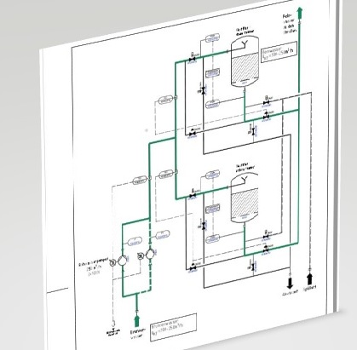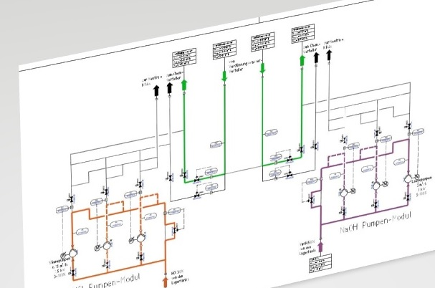
Scope of the components to be renewed:
- Chemical dosing station, divided into acid and caustic module
- 2 double deck gravel filters (Ø 3.000mm * 5.000mm)
- 2 VE lines with a maximum capacity of 250 t/h each
The special challenge of this project is the supply of regenerant chemicals to various existing and new plants by only one chemical dosing station. All process steps of the respective plants have to be considered according to dimensioning, location and chemical requirements.
Gemäß Kundenwunsch soll daher im ersten Schritt die Chemikalien-Dosierstation ersetzt werden.
Special attention was focused on the initial parallel operation of the old and the new station in order to avoid operational failures due to disturbances during commissioning. The design of the piping therefore also takes into account the changeover from the old to the new chemical dosing station.
In order to minimize risks, the chemicals are also mixed immediately after the dosing statio and then fed to the respective places of use.
All planning and construction was based on site inspections and on-site measurements. The existing structures were already taken into account as far as possible in the basic engineering.

