Engineering, Construction and Commissioning for the Renewal of a Sugar Decolorization Plant
In this project, the existing sugar decolorization plant, with a total capacity of maximum 21m³/h and 62°BX, was replaced by a new plant. The design and installation includes a decolorization filter with a downstream cation exchanger. The difficulty of the project was the limited execution time, which was limited to the short time of the shutdown. | 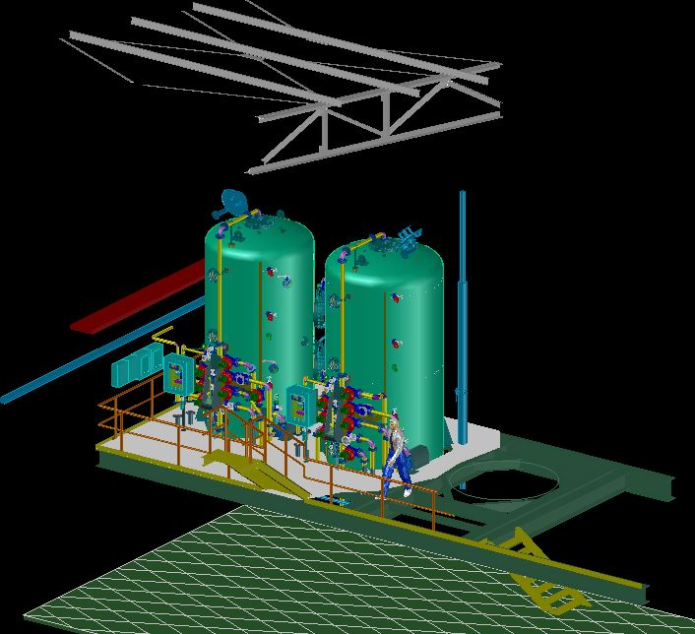
Project Scope:
- Decolorizing Filter ( Ø 2.400 mm * 4.300 mm )
- Cation Exchanger ( Ø 2.600 mm * 4.400 mm )
- 2 Booster Pumps
- 2 Front Piping (prefabricated)
- Fittings + Measurements
- Pneumatic + Electrical Components

Project processing procedure:
KB.tec was commissioned with a "basic engineering" in the preparation of the project. This included the design and control of the process sequences, various installation proposals and the revision of the fittings and measuring points. After all the technical and commercial details had been clarified, KB.tec was also given the task of carrying out the project.
In order to save "valuable time" during the implementation on site, pipe parts, fittings and sub-distribution boxes were pre-assembled on stainless steel frames on KB.tec GmbH premises. This allowed the work on the connecting pipelines to be performed on site within the specified time frame.
The valves are triggered via the new valve terminal groups which are installed in the sub-distribution boxes and controlled by the higher-level control system.
After filling in the filter material, the plant was commissioned with the support of KB.tec GmbH. All process modes were tested with water. Last adjustments of the control system could therefore be run through several times without any danger. Following the trial operation, the plant could be put into operation. Finally, flushing and optimization of the filling quantities was carried out.

Translated with www.DeepL.com/Translator

