Basic Engineering of a Condensate Treatment Plant in Germany
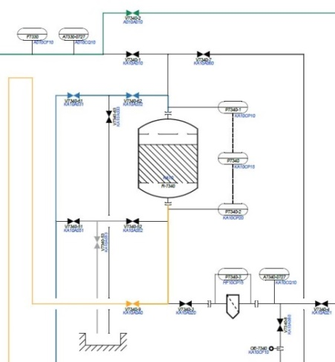
In this project, a condensate treatment plant with a total capacity of maximum 450 t/h was designed and constructed within the framework of basic engineering. The plant consists of three successive treatment steps: two candle filters, cation exchanger, followed by 2 mixed beds. For the pre-treatment two candle filters are used in parallel. The addition of corrosion inhibitors to the feed water increases the load on the cation exchanger. Therefore, a separate cation exchanger is installed upstream of the two mixed beds in parallel, which are used for fine purification of the condensate.
Scope of condensate treatment (main components):
- 2 Candle Filters (Ø 1.400 mm * 2.000 mm)
- 1 Cation Exchanger (Ø 2.800 mm * 2.000 mm)
- 2 Mixed Beds (Ø 2.800 mm * 3.000 mm)
- 3 Resin Catcher
- 2 Tanks for Regenerating Agent, with filling station
- 1 fully automatic Regeneration Station
- Pipeline Planning according to the Customer's Factory Standards
- Equipment-Lists for Components, Fittings and Instrumentation

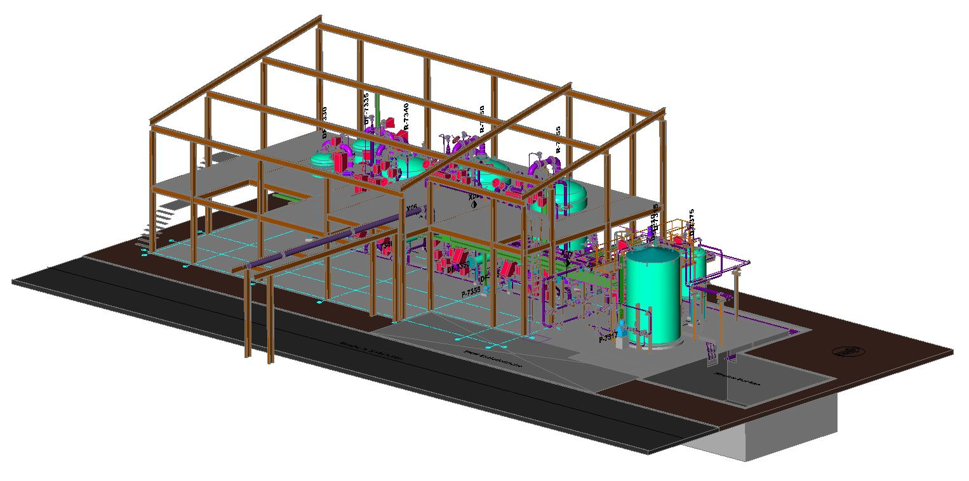
Work Flow
After the process design the construction of the plant components and their layout planning took place. For the layout, the customer specified a defined area. The plant design, including a supplementary proposal for the steel structure planning of the plant housing, was discussed and optimized several times with the customer. During a joint HAZOP, all procedural steps for the safe operation of the plant were examined in advance and the basis for the approval planning of the plant was worked out. At the end of basic engineering, a detailed cost estimate of the planned scope of the plant was submitted.

